Quad-County Legislative Conference
Quad-County Legislative Conference
Branch, Hillsdale, St. Joseph, and Cass Counties
Friday, June 20, 2008, 9:30 AM – 1:30 PM
Human Services Building
570 Marshall Road, Coldwater

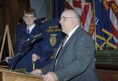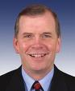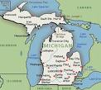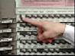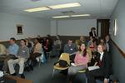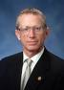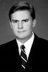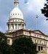

Agenda:
9:30 Introduction.
9:40 Congressman Walberg or
Representative - 7th District.
10:00 Questions.
10:10 Representative Caswell – 58th District.
10:30 Questions.
10:40 Senator Jelinek or Representative –
21st District.
11:00 Questions.
11:10 Networking Break.
11:30 Senator Brown – 16th District.
11:50 Questions.
12:00 Michigan Association of Counties
Legislative Director.
12:20 Questions.
12:30 Michigan Bureau of Elections.
12:50 Questions.
1:00 Summary/Conclusion.

